Overview

Day by Day Rates
This incredible 14-day adventure in Rwanda and Uganda combined offers the opportunity for once-in-a-lifetime wildlife encounters. You’ll visit the Genocide Memorial, Akagera National Park for wildlife in Rwanda then continue to Uganda for gorilla and chimp trekking. You will also have the opportunity to have a safari at Murchison Falls National Park and Queen Elizabeth National Park.

Route
Rwanda
Start | Kigali (Day 1)
Day 2-3 | Akagera NP
Uganda
Day 4 | Lake Bunyonyi
Day 5-6 | Bwindi Impenetrable NP (Gorillas)
Day 7 | Ishasha Sector (Queen Elizabeth NP)
Day 8-9 | Queen Elizabeth NP
Day 10-11 | Kibale NP (Chimps)
Day 12-13 | Murchison Falls NP
End | Entebbe (Entebbe) (Day 14)

Tour Features

Mid-range tour
This mid-range tour uses lodges and hotels.

Private tour
This tour will be organized exclusively for you and won't be shared with others.

Can start any day
If availability permits, this tour can start on any day.

Can be customized
You can request minor changes to the accommodations and destinations of this tour.

Suitable for solo travelers
Solo travelers can book this private tour.

Minimum age of 18 years
The minimum age for this tour is 18 years.

Activities & Transportation
- Activities: game drives, gorilla trekking, chimpanzee trekking & nature hikes/walks
- Game drives: pop-up roof 4x4 vehicle
- Getting around: pop-up roof 4x4 vehicle
- A transfer from and back to the airport is included

Accommodation & Meals
- Additional accommodation before and at the end of the tour can be arranged for an extra cost
- Day 1
Accommodation
Meals
Hotel des Mille Collines Luxury hotel in Kigali (Rwanda)

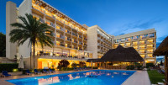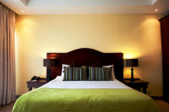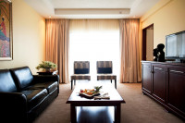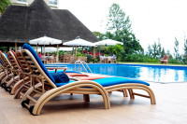

All Meals Included
- Day 2-3
Mantis A Kagera Game Lodge Luxury lodge inside Akagera NP (Rwanda)

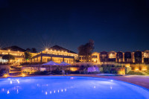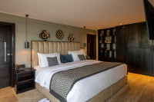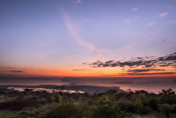

All Meals Included
- Day 4
Arcadia Lodge Lake BunyonyiMid-range lodge at Lake Bunyonyi (Uganda)

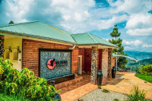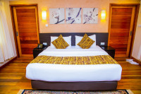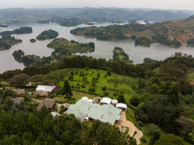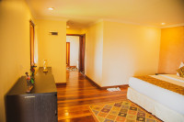

All Meals Included
- Day 5-6
Rushaga Gorilla Lodge Mid-range lodge just outside Rushaga (Bwindi Impenetrable NP, Uganda)

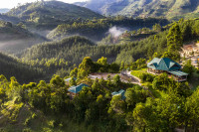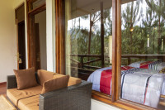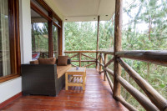

All Meals Included
- Day 7
Topi Lodge Mid-range lodge just outside Ishasha Sector (Queen Elizabeth NP, Uganda)

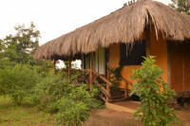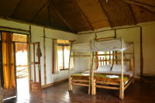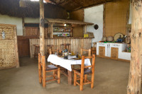

All Meals Included
- Day 8-9
Buffalo Safari Lodge Mid-range lodge just outside Queen Elizabeth NP (Uganda)

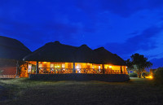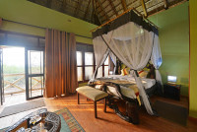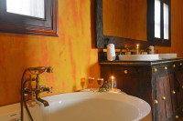

All Meals Included
- Day 10-11
Turaco Treetops Lodge Mid-range lodge bordering Kibale NP (Chimps, Uganda) without fences

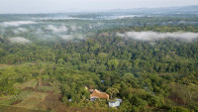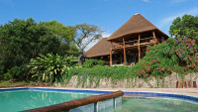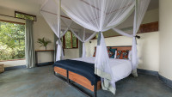
otos

All Meals Included
- Day 12-13
Pakuba Safari Lodge Mid-range lodge inside Murchison Falls NP (Uganda)

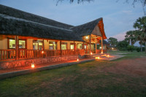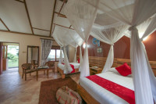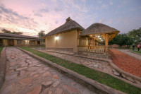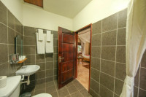

All Meals Included
- Day 14
End of tour
(No accommodation)
Breakfast & Lunch Include

Day by Day
Arrival
- You'll be collected from the airport.
- Accommodation before the tour starts can be arranged for an extra cost.
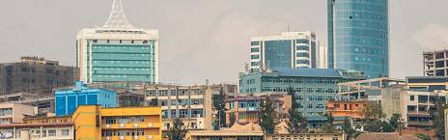
Day 1
Arrive in Kigali
You'll board your international flight to Rwanda’s capital, Kigali. Once you arrive, you will be swiftly escorted by a Ngoni Safaris representative who will transfer you to your chosen accommodation. As this is your first day, you will have time to leisurely explore Rwanda’s lively city.
If you have an early landing, then you’ll have an opportunity to visit the bustling local markets and the Caplaki Craft Co-operative where you’ll find local craftsmen in wooden huts. They'll be selling handicrafts, including jewellery, paintings, batik, fabrics, wood carvings, traditional masks, baskets, bags, scarves and beading.
Main Destination:
Kigali (Rwanda)
Accommodation:
Hotel des Mille Collines
- Luxury hotel located in Kigali (Rwanda)

Meals & Drinks:
- All meals included
- Drinking water (Other drinks not included)

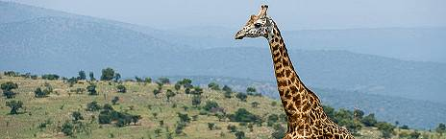
Day 2
Visit the Genocide Memorial and then Transfer to Akagera National Park
You will be picked up from your hotel/lodge by a Ngoni Safaris guide who will drive you to the Genocide Memorial before continuing to Akagera National Park which is about two hours away from Kigali.
You will have lunch at the lodge and enjoy a boat ride on Lake Ihema in the afternoon.
Main Destination:
Akagera National Park (Rwanda)
Best Time To Visit June to September and mid-December to mid-February (It is drier and wildlife is easier to spot)
High Season June to September (The park is busiest at weekends)
Best Weather June to October (Sunny, but not too hot)
Accommodation:
Mantis Akagera Game Lodge
- Luxury lodge located inside Akagera NP (Rwanda)
Meals & Drinks:
- All meals included
- Non-alcoholic drinks
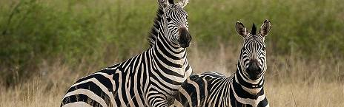
Day 3
Game Drive at Akagera National Park
You will start the day with an early morning game drive through the park in search of lions, elephants, buffalos, Masai giraffes and many others. You will return to the lodge for lunch. You will have another game drive in the afternoon in search of more animals including gazelles, impala, baboons, oribi, Butchel’s zebras, topis, bush babies, leopards, bushbucks, and elands.
Main Destination:
Akagera National Park (Rwanda)
Accommodation:
Mantis Akagera Game Lodge
- Luxury lodge located inside Akagera NP (Rwanda)
Meals & Drinks:
- All meals included
- Drinking water (Other drinks not included)
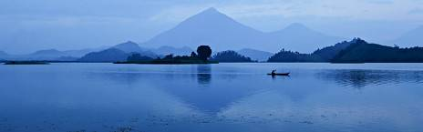
Day 4
Transfer to Lake Bunyonyi for Relaxation
You will have breakfast and transfer to Lake Bunyonyi. Lake Bunyonyi is framed by lush, green-terraced hills that reach a height of (2,200 – 2,478m) with 29 islands of various shapes and sizes scattered across the water. This makes it most magical — you could admire them all day. You shall have an exciting boat ride on Lake Bunyonyi. In the afternoon, you may have optional activities; a canoe boat ride, a swim in the Bilharzia free lake, you may also explore a nearby village. Residents are happy about your visit and are open to explaining their daily lives.
Main Destination:
Lake Bunyonyi (Uganda)
Accommodation:
Arcadia Lodge Lake Bunyonyi
- Mid-range lodge located at Lake Bunyonyi (Uganda)
Meals & Drinks:
- All meals included
- Drinking water (Other drinks not included)
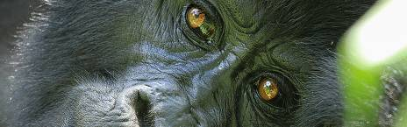
Day 5
Boat Rides at Lake Bunyonyi then Transfer to Bwindi Impenetrable National Park
You will be up and have your breakfast served then have a morning canoe boat on Lake Bunyonyi. Thereafter, transfer to Bwindi Impenetrable National Park. Bwindi is a big habitat for mountain gorillas in Uganda (harbouring an estimated 400 mountain gorillas—roughly half of the world’s population), including several habituated groups, that can be tracked. With a strenuous day ahead, you will do less on arrival but just check in your accommodation and relax as you prepare for the Bwindi gorilla trekking experience the following day.
Main Destination:
Bwindi Impenetrable National Park (Gorillas)
Best Time To Visit June to August and December to February (Gorilla trekking is easiest)
High Season June to September (Gorilla permits are scarce)
Best Weather June to July and December to February (Less rainfall)
Wildlife in Bwindi Impenetrable NP
Gorilla Common
Accommodation:
Rushaga Gorilla Lodge
- Mid-range lodge just outside Rushaga (Bwindi Impenetrable NP, Uganda)
Meals & Drinks:
- All meals included
- Drinking water (Other drinks not included)

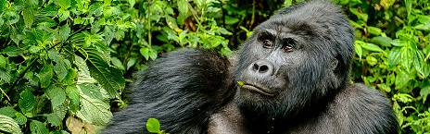
Day 6
Gorilla Tracking in Bwindi Impenetrable National Park
You will wake up early morning, have breakfast and have a briefing before entering the forest for gorilla tracking. Encountering the rare and endangered mountain gorillas of Bwindi Impenetrable National Park is an experience of a lifetime. Half of the world’s population of gorillas live under the mist-covered canopies of Uganda’s oldest and most biologically diverse rainforest. In the company of an experienced park ranger, you will be tracking the whereabouts of one of the nine habituated family groups who live in the park. Depending on the location of the gorillas on any given day, the walk can take anywhere from 2 to 7 hours. Once the family of gorillas has been located, you'll settle into your surroundings and enjoy the hour you have to quietly observe these fascinating primates whose habits and mannerisms remind us so much of our own.
If time and energy allow, you will visit the Batwa people and learn about their culture, way of life and know their origin.
Main Destination:
Bwindi Impenetrable National Park (Gorillas)
Accommodation:
Rushaga Gorilla Lodge
- Mid-range lodge just outside Rushaga (Bwindi Impenetrable NP, Uganda)
Meals & Drinks:
- All meals included
- Drinking water (Other drinks not included)

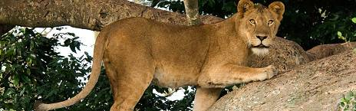
Day 7
Transfer to Ishasha Sector for Tree-Climbing Lions
You'll have breakfast then set off to Ishasha Sector—famously known for its resident tree-climbing lions. The chance of spotting these lions is about 70% though sometimes they are really hard to spot (most especially when they’re down in the grassland looking for prey). Hoping you get the chance to spot them, the sight will be spectacular! You will also be able to see other wildlife such as the Uganda kob, Cape buffalos, elephants and warthogs in addition to the tree-climbing lions. Thereafter, you'll head to the accommodation for relaxation, dinner and later an overnight stay.
Main Destination:
Ishasha Sector (Queen Elizabeth NP, Uganda)
Best Time To Visit January to February and June to July (Dry seasons)
High Season June to September (Peak time for Uganda)
Best Weather June to July and January to February (Less rainfall)
Wildlife in Queen Elizabeth NP
Chimpanzee Occasional ,Elephant Common ,Lion Common ,Buffalo Common , Hippo Abundant, Leopard Occasional
Accommodation:
Topi Lodge
- Mid-range lodge just outside Ishasha Sector (Queen Elizabeth NP, Uganda)
Meals & Drinks:
- All meals included
- Drinking water (Other drinks not included)

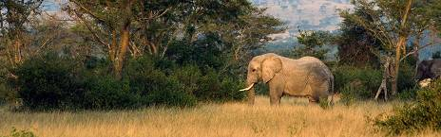
Day 8
Drive to Queen Elizabeth National Park
You will have breakfast then transfer to Queen Elizabeth National Park. You will arrive at your accommodation, check in, have lunch, relax at the hotel and then head for an evening game drive. The park is home to 618 bird species which is the 6th highest diversity in the world and the highest in Africa making it a perfect destination for Uganda birding safaris, in addition to 10 primate species like chimpanzees and 95 mammals including big game.
Main Destination:
Queen Elizabeth National Park (Uganda)
Accommodation:
Buffalo Safari Lodge
- Mid-range lodge located just outside Queen Elizabeth NP (Uganda)
Meals & Drinks:
- All meals included
- Drinking water (Other drinks not included)
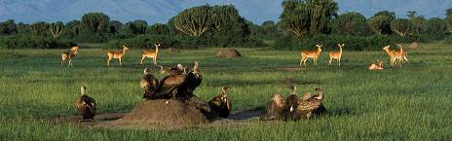
Day 9
Morning Game Drive and Afternoon Boat Cruise at Kazinga Channel
You'll wake up early and have your breakfast. You will then proceed for a morning game drive in the park, along the Kasenyi Plains and be on the look for lions, elephants, leopards (though hard to spot), bushbucks, Cape buffaloes, waterbucks, giant forest hogs, Uganda kobs among others. You'll return to your accommodation for some rest time and lunch.
In the afternoon, you will go for your boat cruise at Kazinga Channel and then transfer to Kibale National Park.
Main Destination:
Queen Elizabeth National Park (Uganda)
Accommodation:
Buffalo Safari Lodge
- Mid-range lodge located just outside Queen Elizabeth NP (Uganda)
Meals & Drinks:
- All meals included
- Drinking water (Other drinks not included)
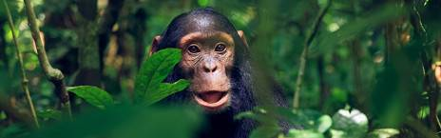
Day 10
Transfer to Kibale Forest National Park
After early morning breakfast, we will pick you up from a hotel or guesthouse of your choice in Entebbe or Kampala and leave for Kibale National Park. We will stop on the way for lunch and beautiful scenery. In the afternoon, you will arrive at Kibale National Park, sleeping with the noises of the tropical rainforest.
Main Destination:
Kibale National Park (Chimps)
Best Time To VisitJanuary to February and June to July (Chimp trekking is easiest)
High SeasonJune to September (Peak time for Uganda)
Best WeatherJanuary to February and June to July (Least rain)
Wildlife in Kibale NP
Chimpanzee Common
Accommodation:
Turaco Treetops Lodge
- Mid-range lodge bordering Kibale NP (Chimps, Uganda) without fences
Meals & Drinks:
- All meals included
- Drinking water (Other drinks not included)
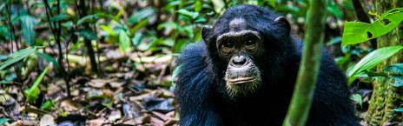
Day 11
Chimp Tracking and the Bigodi Swamp Walk
You will have breakfast and head to the trekking point where you will receive some briefing on the dos and don’ts during chimp trekking. Thereafter, you will proceed to trek the chimps in the Kibale Forest. An experienced ranger guide will take you chimp tracking and you will marvel at the sights of primates here. Once you locate the chimpanzees, you will have a full hour with them. You will return to your accommodation for some rest time and lunch. Later, you will go out for the Bigodi swamp walk. The Bigodi Wetland Sanctuary is a fascinating area, located in the Magombe swamp. This area is recognized for its extensive array of biodiversity among which are several primate species like the baboons, black and white Colobus monkeys, vervet monkeys and the L’Hoest monkey. The Bigodi is also a paradise for bird watchers. Among the major bird species within the sanctuary is the grand blue turaco.
Main Destination:
Kibale National Park (Chimps)
Accommodation:
Turaco Treetops Lodge
- Mid-range lodge bordering Kibale NP (Chimps, Uganda) without fences
Meals & Drinks:
- All meals included
- Drinking water (Other drinks not included)
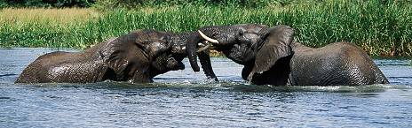
Day 12
Transfer to Murchison Falls National Park
After breakfast, you will set off for the drive to Murchison Falls National Park. You will be there at around lunchtime. When you have finished your lunch, it is time to experience the top of the falls. It is an amazing feeling to stand there enjoying the view and hearing the water roar. You will have a relaxed evening at the lodge.
Main Destination:
Murchison Falls National Park (Uganda)
Best Time To VisitDecember to February (Easier to spot animals)
High SeasonJune to September (Peak time for Uganda)
Best WeatherJune and July (Less rain and lower temperatures)
Wildlife in Murchison Falls NP
Chimpanzee Occasional, Elephant Common, Giraffe Common, Lion Common, Buffalo Common, Hippo Abundant
Accommodation:
Pakuba Safari Lodge
- Mid-range lodge located inside Murchison Falls NP (Uganda)
Meals & Drinks:
- All meals included
- Drinking water (Other drinks not included)
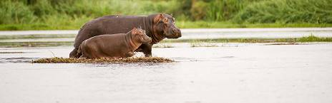
Day 13
Morning Game Drives and Boat Cruise and Murchison Falls National Park
After an early breakfast, it is time to explore the park. On the game drive, you will spot as many animals as possible. While driving through the park, you can come eye-to-eye with the African animal kingdom. Hopefully, you see them all; elephants, giraffes, buffaloes, lions, leopards, different species of antelope and many tropical birds. They are all there! A professional ranger with extensive knowledge of the park and its inhabitants will join you in your car. The park is especially known for its massive elephant population, the huge array of bird species and big herds of buffalo.
The afternoon boat safari towards Murchison Falls is a very special activity. It takes approximately 3 hours and goes along the Victoria Nile to the base of the Falls. You can imagine; this boat safari will show you breathtaking scenery.
Main Destination:
Murchison Falls National Park (Uganda)
Accommodation:
Pakuba Safari Lodge
- Mid-range lodge located inside Murchison Falls NP (Uganda)
Meals & Drinks:
- All meals included
- Drinking water (Other drinks not included)
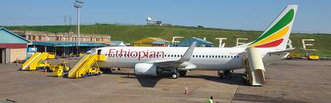
Day 14
Transfer to Ziwa for Rhino Tracking then Entebbe Airport
After breakfast, you will transfer to Ziwa Rhino Sanctuary for rhino tracking. After rhino tracking, you will have your lunch and then start your journey to Entebbe Airport for your flight.
Main Destination:
Entebbe International Airport (Entebbe, Uganda)
Accommodation:
No accommodation (End of tour)
Meals & Drinks:
- Breakfast & lunch (Dinner not included)
- Drinking water (Other drinks not included)
End of tour
- Additional accommodation can be arranged for an extra cost.
- You'll be dropped off at the airport.

Included
- Park fees(For non-residents)
- Gorilla permits(One per person, non-resident)
- Chimp permits(One per person, non-resident)
- All activities(Unless labeled as optional)
- All accommodation(Unless listed as upgrade)
- A professional driver/guide
- All transportation(Unless labeled as optional)
- All Taxes/VAT
- Roundtrip airport transfer
- Meals(As specified in the day-by-day section)
- Drinks(As specified in the day-by-day section)
Excluded
- International flights(From/to home)
- Additional accommodation before and at the end of the tour
- Tips(Tipping guideline US$10.00 pp per day)
- Personal items(Souvenirs, travel insurance, visa fees, etc.)
- Government imposed increase of taxes and/or park fees
Rates
Important to Know
- Rates are per person and exclude the international flight from/to your home country.
- This tour is unavailable for children.
Rates Per Person
Start dates | Solo1 room | 2+ peopleSharing rooms
Jan 1, 2026 - Dec 31, 2026 | $6,600 | $5,500
Jan 1, 2027 - Dec 31, 2027 | $6,600 | $5,500

